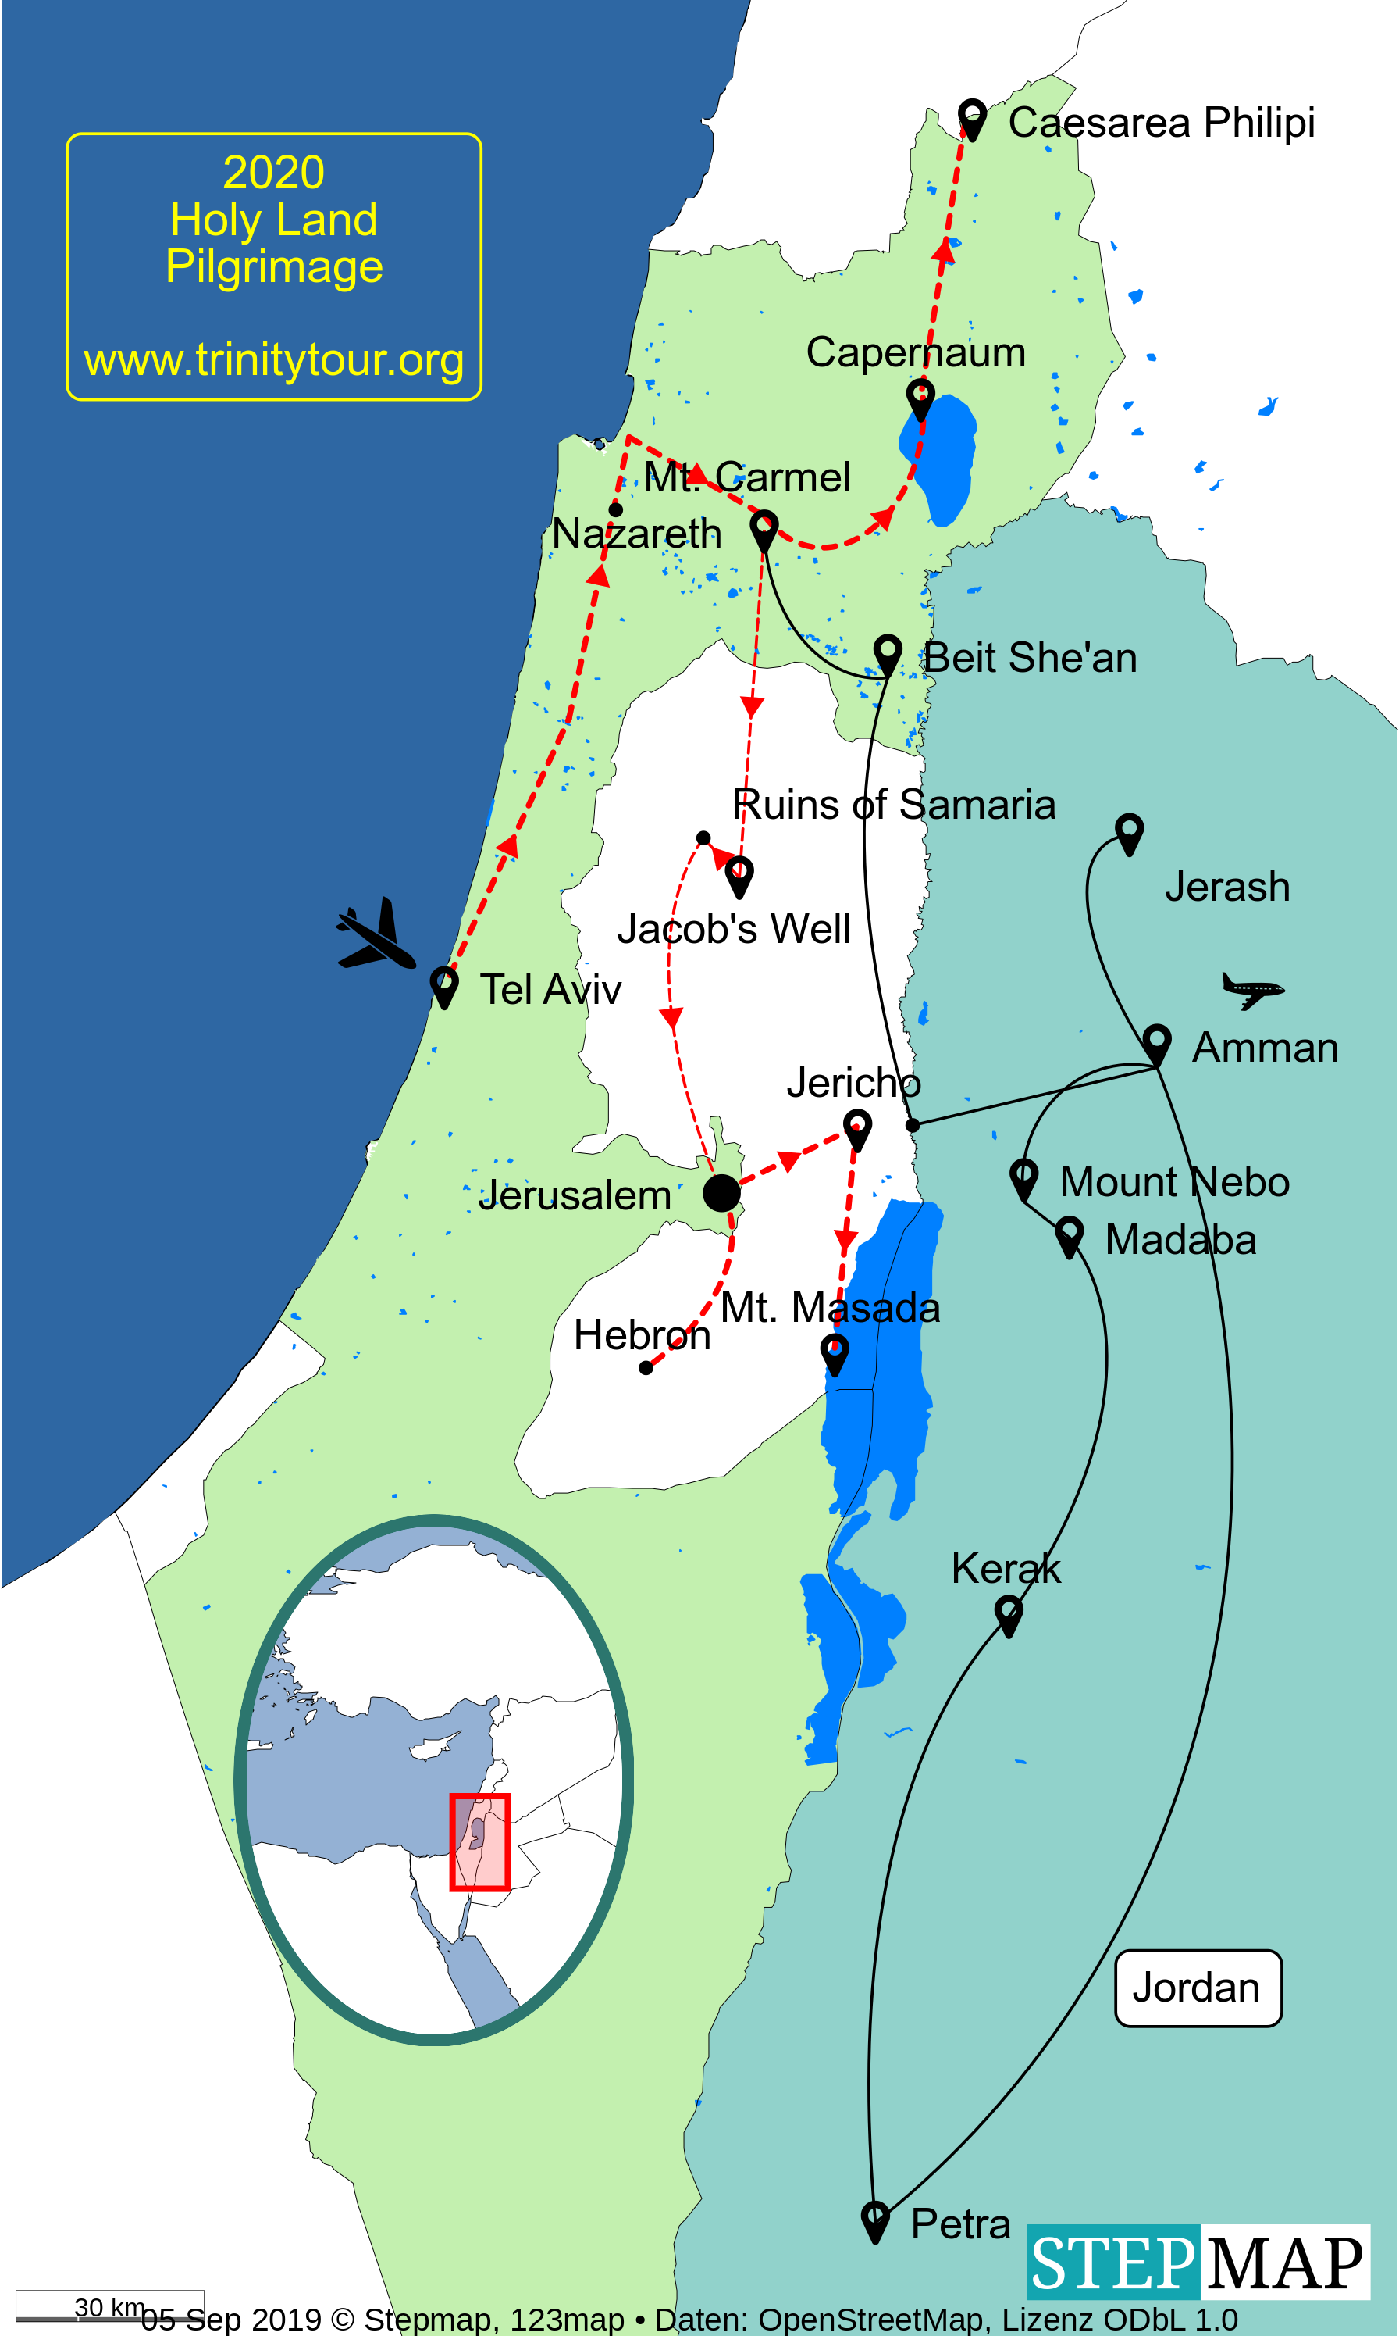

**May 22 – June 3, 2020**

*With Rev. Canon Vicars Hodge & Bishop Terry Dance*

***The spiritual experience of a lifetime.***

**Trinity Anglican Church**

[www.trinitytour.org](http://www.trinitytour.org)

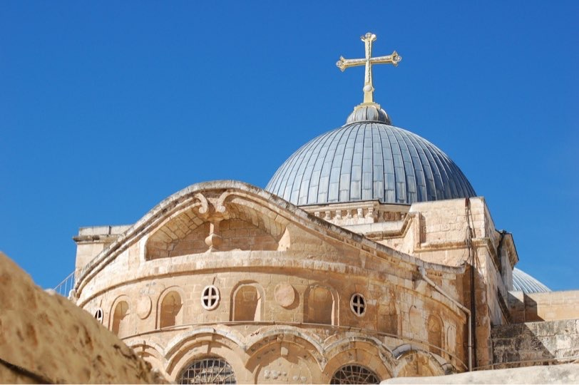

* **Twelve Days/11 Nights in the Holy Land May 22 – June 3, 2020.**  Visit the most important holy sites in the *footsteps of Jesus*. Meet and worship with local believers.
* **5 Day/4 Night Extension – visit Petra and other sites in the Kingdom of Jordan**. May 18-23, 2020
* **Optional Jerusalem Extension June 3 & 4**
* Travel by modern air-conditioned coach with WiFi. Expert local guides and qualified clergy share as we visit key sites of importance to Christians in the lands where our faith began.

For all the details please visit: [www.trinitytour.org](http://www.trinitytour.org)

You’re Invited

See Itinerary and Details at [www.trinitytour.org](http://www.trinitytour.org/)

Trinity Anglican Church

1194 Murphy Rd., Sarnia, ON N7S 2Y2

519 542 9261

[hodgev@gmail.com](mailto:vhodge@trinity.sarnia.net)

**Pilgrimage 2020**

Holy Land Pilgrimage

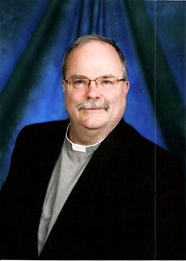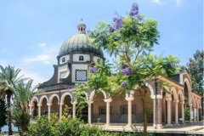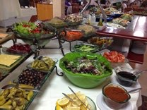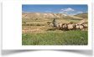

Our **Jordan Extension** preceeds the principal pilgrimage. We fly from Toronto to Amman on May 18. Visit the ancient city of Amman, the Roman ruins of Jerash, the amazing UN Heritage site of Petra, Kerak, Madaba, and Mount Nebo! We link up with the rest of our group in Nazareth on May 23.

After the main pilgrimage, the **Jerusalem Extension** allows two extra days at leisure in Jerusalem.

**Optional Extension(s)**

**The Rev. Canon Vicars Hodge**

An Anglican Clergyman and experienced Pilgrimage leader, Vicars is recently retired from service as Rector of Trinity Church, Sarnia and Canon Missioner of the Diocese of Huron. He has a keen interest in the Bible and the people and history of the Holy Land. His insights will add to the expert local tour guides who will be with us every step of the way. Canon Vicars will be accompanied by his wife, Carole.

**This is a comprehensive pilgrimage** – the itinerary is on-line at [www.trinitytour.org](http://www.trinitytour.org) Each day will bring new adventures! Some highlights:

**In Galilee**, we will visit the Mount of the Beatitudes, Cana, Nazareth, Capernaum, and sail on the Sea of Galilee! Visit Samaria, Jacob’s Well, Caesarea, Mt. Carmel, and Mt Tabor.

Then, we explore **Jerusalem** and region once called Judah. We explore the Old City, the Temple Mount, the Mount of Olives, worship in the Garden of Gethsemane, and walk the Via Dolorosa. We visit Bethlehem, Hebron, Jericho, Masada, Qumran & the Judean wilderness – even float on the Dead Sea.

**Holy Land Pilgrimage Highlights**

**Bishop Terry Dance**

Bishop Terry is a beloved preacher/teacher/Bible Study leader. He has a real gift for making scripture come alive and his presence on our pilgrimage will enrich the experience. Before his retirement in 2015, he served as a Suffragan Bishop in the Anglican Diocese of Huron. Bishop Terry will be accompanied by his wife, Diane.

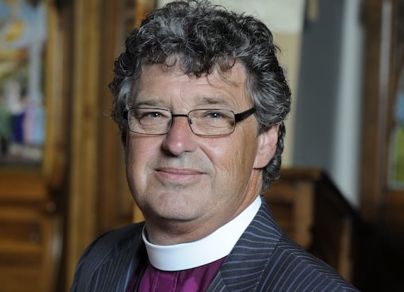

St. Jerome called the Holy Land “***The 5th Gospel***” when you visit, the Bible’s stories come to life. For 1700 years, Christians have been making pilgrimages to the Holy Land to deepen their faith. Travel with us in the land where Jesus walked, meet and worship with local Christians, grow in faith and form lifetime memories. **This will be the spiritual adventure of a lifetime!**

THE Experience of a LIFETIME

Mount of the Beatitudes beside the Sea of Galilee.

Breakfast & Dinner at our hotel. Lunch at restaurants.

**What will it cost?**

Cost per person (dbl. occupancy) will be approximately US$3,700 plus airfare for the primary pilgrimage. The optional Jordan extension is approx. $1250. For updates check the website. Our package will include nearly everything: transfers, hotels, porterage, guides, drivers, admissions, all meals, and even tips. **All details are now online at** [**www.trinitytour.org**](http://www.trinitytour.org)

