Bulletin Announcements

Either cut and paste for bulletin – or you can download these bulletin files on our website.
We have both DOC that you can edit and PDF files on the page.

Download as PDF or DOC files at http://trinitytour.org/downloads.html

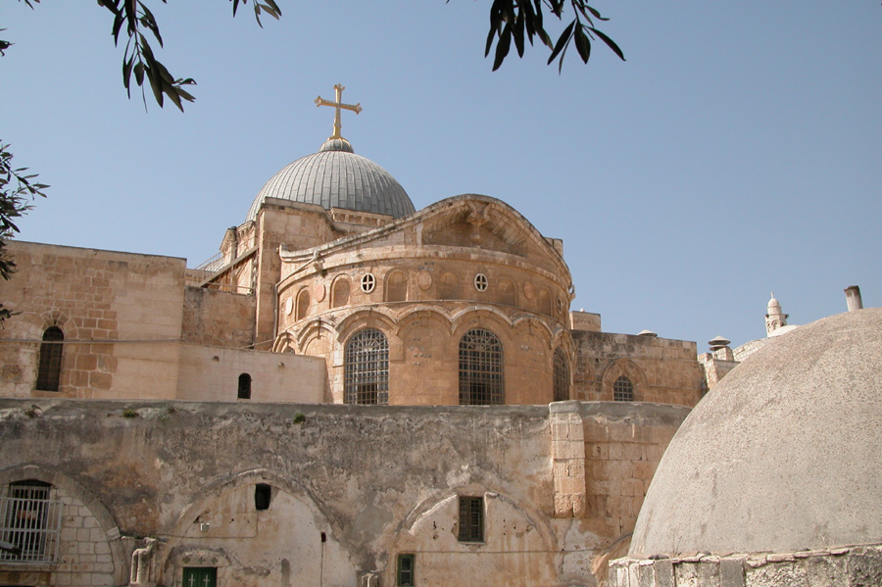
Holy Land Pilgrimage. Canon Vicars Hodge and Bishop Terry Dance are leading a pilgrimage tour (April 30 – May 14, 2019). You’re invited to join the group for the spiritual adventure of a lifetime. St. Jerome called the Holy Land The 5th Gospel because those who visit rarely leave the same as they arrive. To walk where Jesus walked and meet the people of the land brings the Bible stories to life. For full information: www.trinitytour.org

Holy Land Pilgrimage. Canon Vicars Hodge and Bishop Terry Dance are leading a pilgrimage tour (April 30 – May 14, 2019). You’re invited to join the group for the spiritual adventure of a lifetime. St. Jerome called the Holy Land The 5th Gospel because those who visit do not leave the same as they arrive. To walk where Jesus walked and meet the people of the land brings the Bible stories to life. For details: www.trinitytour.org

