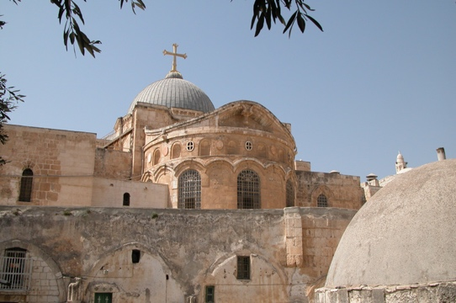
Holy Land Pilgrimage. Canon Vicars Hodge and Bishop Terry Dance are leading a pilgrimage tour (April 9-21, 2021). You’re invited to join the group for the spiritual adventure of a lifetime. St. Jerome called the Holy Land “The 5th Gospel” because those who visit rarely leave the same as they arrive. To walk where Jesus walked and meet the people of the land brings the Bible stories to life. For full information: www.trinitytour.org

